Project Report
On
Computer Networking: Concepts (CSE3751)


Smart City Traffic Surveillance Network

Submitted by:

Name: Deepti Prasad Sahu Regd. No.: 2341019220
Name: Neha Sahu Regd. No.: 2341019249
Name: Trideep Sahu Regd. No.: 2341019268
Name: Rudranarayan Sarangi Regd. No.: 2341019339
Name: Shiva Shukla Regd. No.: 2341019461

B. Tech. BRANCH 5th Semester (Section – 23412N2 )
INSTITUTE OF TECHNICAL EDUCATION AND RESEARCH
(FACULTY OF ENGINEERING)
SIKSHA ‘O’ ANUSANDHAN (DEEMED TO BE UNIVERSITY), BHUBANESWAR, ODISHA

i

Declaration

We, the undersigned students of B. Tech. of COMPUTER SCIENCE AND ENGINEERING Department hereby declare that we own the full responsibility for the information, results etc. provided in this PROJECT titled “Smart City Traffic Surveillance Network” submitted to Siksha ‘O’ Anusandhan (Deemed to be University), Bhubaneswar for the partial fulfillment of the subject Computer Networking: Concepts (CSE 3751). We have taken care in all respect to honor the intellectual property right and have acknowledged the contribution of others for using them in academic purpose and further declare that in case of any violation of intellectual property right or copyright we, as the candidate(s), will be fully responsible for the same.

Name: DEEPTI PRASAD SAHU Name: Neha Sahu
Regd. No.: 2341019220 Regd. No.: 2341019249

Name: Trideep Sahu Name: Rudranarayana Sarangi
Regd. No.: 2341019268 Regd. No.: 2341019339

Name: SHIVA SHUKLA
Regd. No.: 2341019461

Date:1/5/2025

Place: ITER, Siksha ‘O’ Anusandhan University

Abstract

This project focuses on the design and implementation of a centralized traffic surveillance network for a smart city, logically divided into four distinct zones: North, East, South, and West. Each city zone is equipped with IP-based surveillance cameras connected to a local access switch and a dedicated zone router. All zone routers are integrated into a Central Monitoring Centre (CMC) via a core switch and a central router.

The network implementation features several key technical configurations to ensure seamless operation:
- Centralized DHCP Management: A DHCP service is hosted on the CMC server to dynamically allocate IP addresses to surveillance cameras across all zones, starting from .50 to maintain network organization.
- Static Inter-Zonal Routing: Communication between city zones and the CMC is facilitated through manually configured static routing, ensuring reliable data transmission for live feeds and recordings.
- Secure Public Access via Static NAT: The CMC router utilizes Static Network Address Translation (NAT) to map the internal server to a public IP address. This allows vehicle owners on a public network to receive traffic alerts and violation notices while maintaining the security of the internal city network.
- Logical Segmentation: Each zone is isolated within its own subnet to ensure a scalable and organized network hierarchy.

The successful deployment of the network was verified through end-to-end ping tests, DHCP lease assignments, and NAT translation table audits within the Cisco Packet Tracer environment. The results demonstrate a maintainable and scalable infrastructure suitable for real-world smart city surveillance requirements.

Contents

Serial  No. | Chapter No. | Title of the Chapter | Page No.
1. | 1 | Introduction
2. | 2 | Problem Statement
3. | 3 | Methodology
4. | 4 | Results and interpretation
5. | 5 | Conclusion
7. |  | References

- Introduction

This project designs a smart traffic system that acts as the "eyes and ears" of a city by connecting four major zones—North, East, South, and West—into one synchronized network. By giving each zone its own dedicated subnet, we ensure that the network remains secure, organized, and easy to manage.
+3
To keep things running smoothly, a centralized DHCP server at the Monitoring Centre automatically assigns IP addresses to every camera as it comes online. We then established "digital pathways" using static routing to ensure live video feeds travel directly from the streets to the authorities without delay.
+3
Finally, we implemented Static NAT to bridge the gap between the city’s private network and the public. This allows the system to send real-time alerts or violation notices to vehicle owners securely, protecting the city's internal data while keeping citizens informed.

- Problem Statement

Design and implement a centralised vehicle traffic monitoring cum controlling network for a city that comprises different traffic zones. The network should support segmentation, inter-zonal routing, and controlled traffic forwarding in different routes, along with alerting the vehicle owners through proper message communication.

I. Overview & Objects
The goal is to design a "Smart City" network that connects traffic surveillance from four geographic zones (North, East, South, and West) to a Central Monitoring Centre (CMC) for live oversight and public alerting.
Cisco Packet Tracer Objects:
- End Devices: IP-based webcams for street monitoring and a Central Server (Server0) for data storage and DHCP.
- Intermediary Devices: Five 2911 Routers (Zone and CMC) and 2960 Switches for core connectivity.
- Public Network: A dedicated router and PC representing the Vehicle Owner receiving traffic notifications.
II. Constraints
- Static Routing: Mandatory use of manual static routes instead of dynamic protocols for all inter-zonal traffic.
- DHCP Relay: Use of ip helper-address is required since cameras and servers reside on different subnets.
- Secure Access: Public communication is restricted to a Static NAT bridge to keep internal surveillance data private.
- Segmentation: Strict adherence to assigned IP ranges per zone to manage broadcast traffic and maintain organization.

- Methodology

I. Network Architecture
The city is organized into a hub-and-spoke model.
- Four Traffic Zones: North, East, South, and West, each acting as a standalone branch with its own cameras and local router.
- Central Monitoring Centre (CMC): The heart of the network containing the Core Switch, the CMC Router (Router2), and the CMC Server (Server0).
- Public Portal: A standalone network representing the "Vehicle Owner" connected to the CMC via a public-facing link.
II. IP Addressing & Segmentation
We utilized a structured private IP scheme to ensure logical separation and efficient management:
- Zone Private Subnets:
  - North: 192.168.10.0/24 — Gateway: 192.168.10.3.
  - East: 192.168.20.0/24 — Gateway: 192.168.20.3.
  - South: 192.168.30.0/24 — Gateway: 192.168.30.3.
  - West: 192.168.40.0/24 — Gateway: 192.168.40.3.
- CMC Internal Network: 192.168.50.0/24 — Server IP: 192.168.50.1, Router Gateway: 192.168.50.2.
- Public Network: Vehicle owner operates on 200.0.0.1 with the router public interface at 200.0.0.2.
III. High-Level Device Configuration
- Centralized DHCP: The DHCP service was enabled on Server0, with four distinct pools created to manage IP assignments for all city zones automatically.
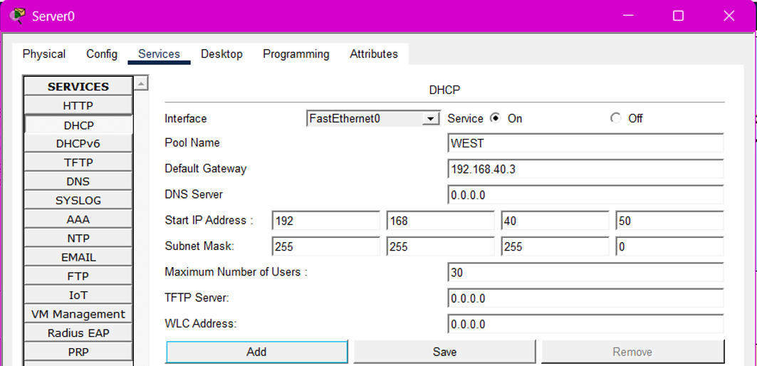
Example:

- DHCP Relay Agents: Each zone router was configured with an ip helper-address 192.168.50.1 on its LAN-facing interface to forward camera requests to the central server.
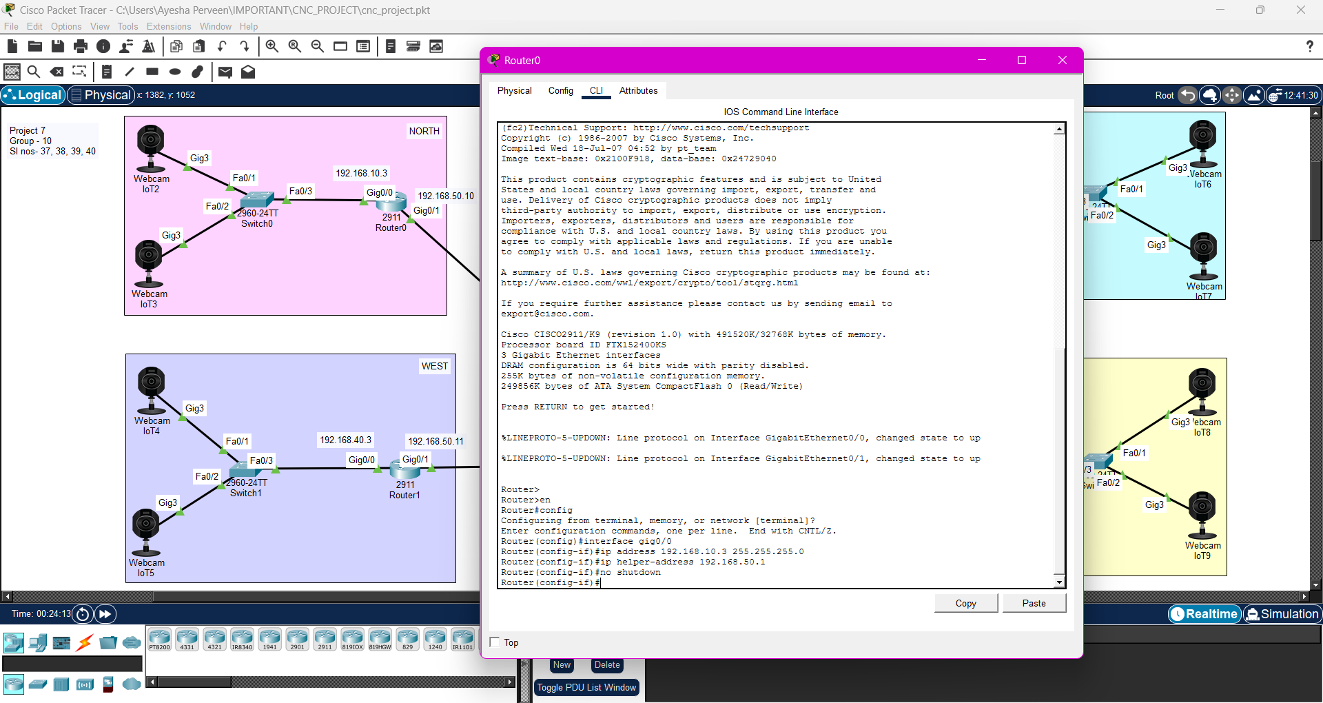
GROUP-15
SL NO-57,58,59,
60,61

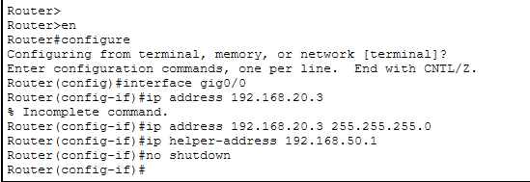

- Static Highway (Routing):
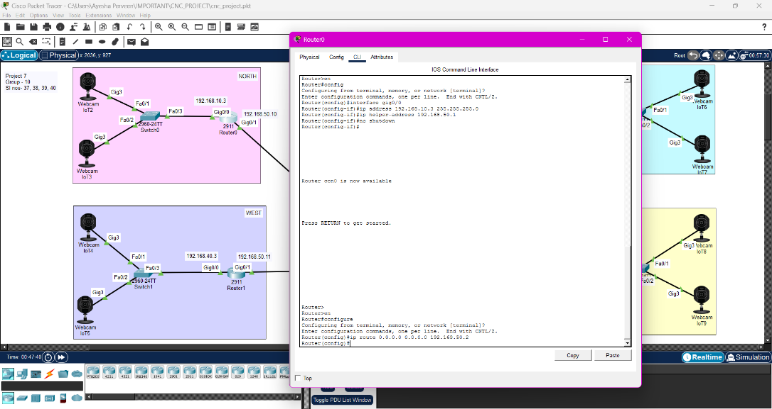
  - Zone routers use a default route pointing to the CMC.
GROUP-15
SL NO-57,58,59,
60,61

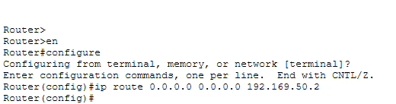

  - The CMC router (Router2) uses specific static routes to identify the paths back to each zone.
- Secure Public Bridge (NAT): Static NAT was implemented on Router2 to map the private CMC server (192.168.50.1) to a public-facing IP (200.0.0.10).
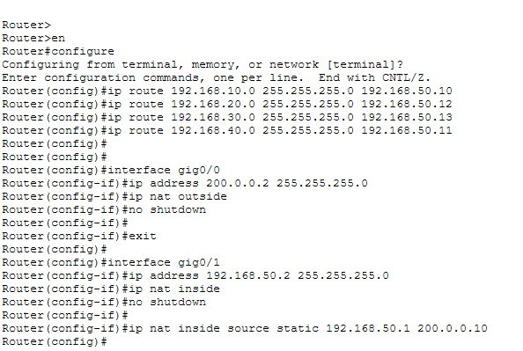

IV. Verification Steps Performed
- DHCP Lease Audit: Verified that webcams successfully requested and received IP addresses from their designated zone pools.
- Relay Verification: Confirmed ip helper-address functionality by checking connectivity between cameras and the central server.
- Routing Audit: Performed successful pings from zone routers to the CMC router to verify path availability.
- NAT Confirmation: Used the show ip nat translations command on Router2 to verify the active mapping between the private server and the public world.
- End-to-End Connectivity: Successfully pinged from the CMC Server to the Vehicle Owner PC to prove message communication across the NAT gateway.

- Results & Interpretation
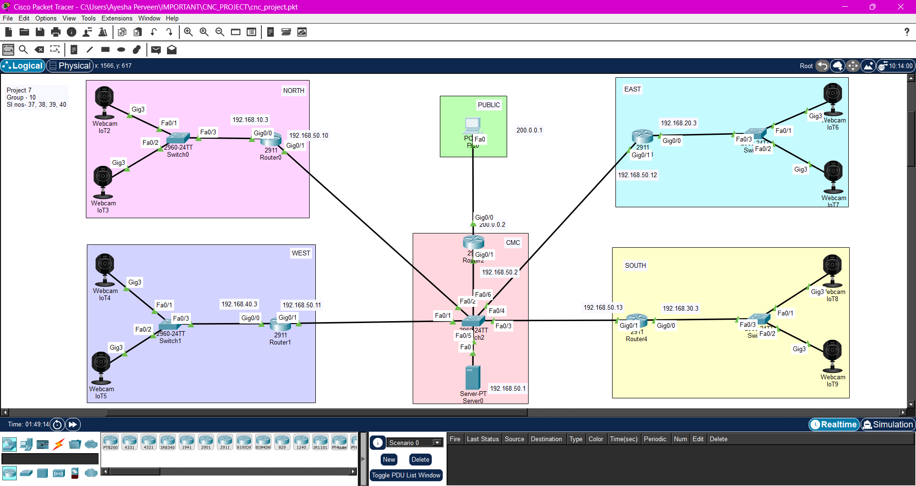
- TOPOLOGY:
GROUP-15
SL NO-,57,58,59,
60,61

Analysis : This screenshot displays the complete logical layout of the Smart City network. It provides a clear visibility of the four city zones (North, East, South, West) connected to the Central Monitoring Centre (CMC) and the public network. It confirms the physical connectivity of all routers, switches, servers, and IP webcams.
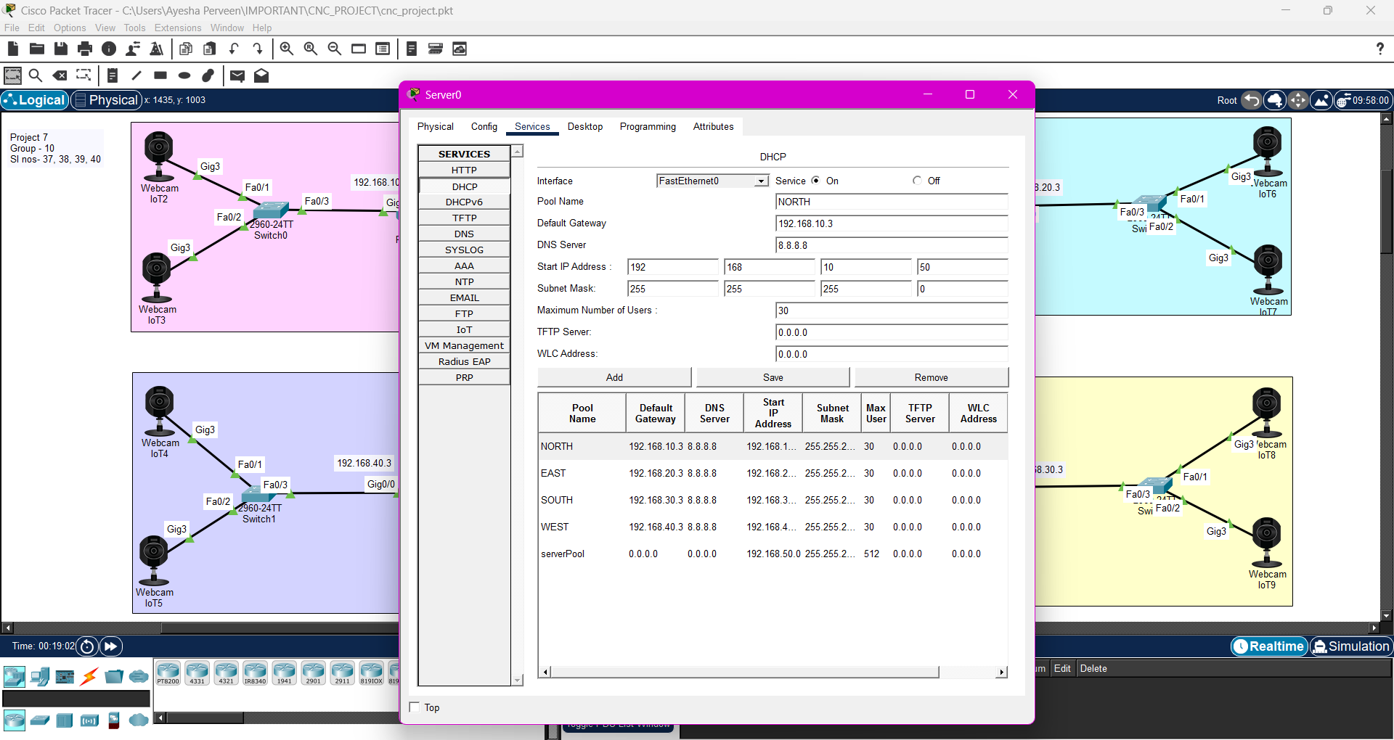
- DHCP Pool Configuration
GROUP-15
SL NO-,57,58,59,
60,61

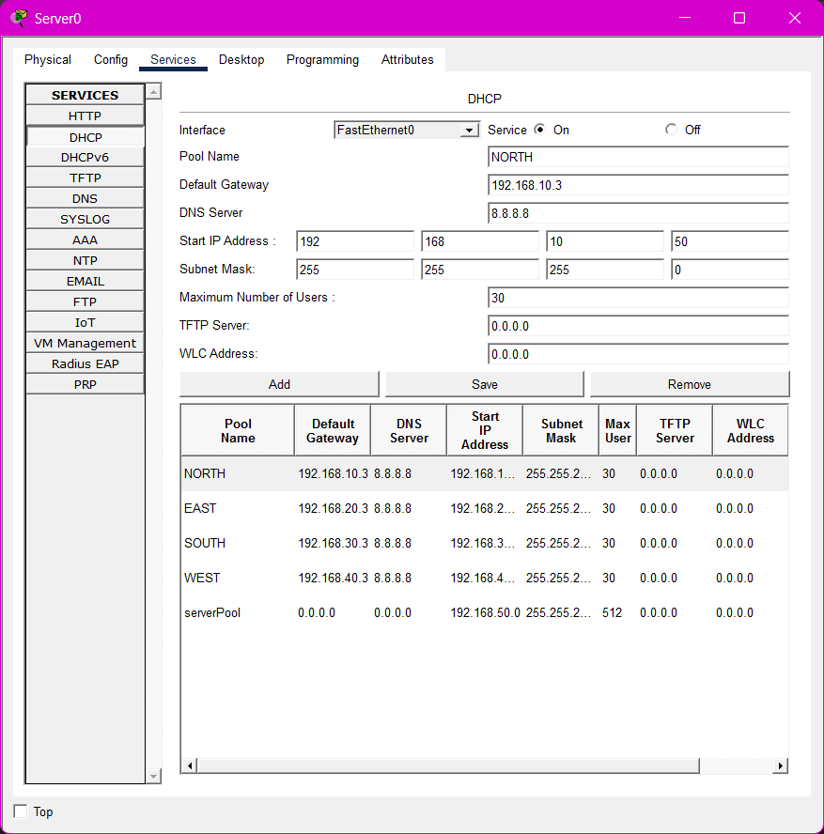
- Description: A capture of the Server0 DHCP services tab showing the defined IP pools.
- Purpose: It proves that unique subnets and gateways were created for the North, East, South, and West zones to ensure logical segmentation.

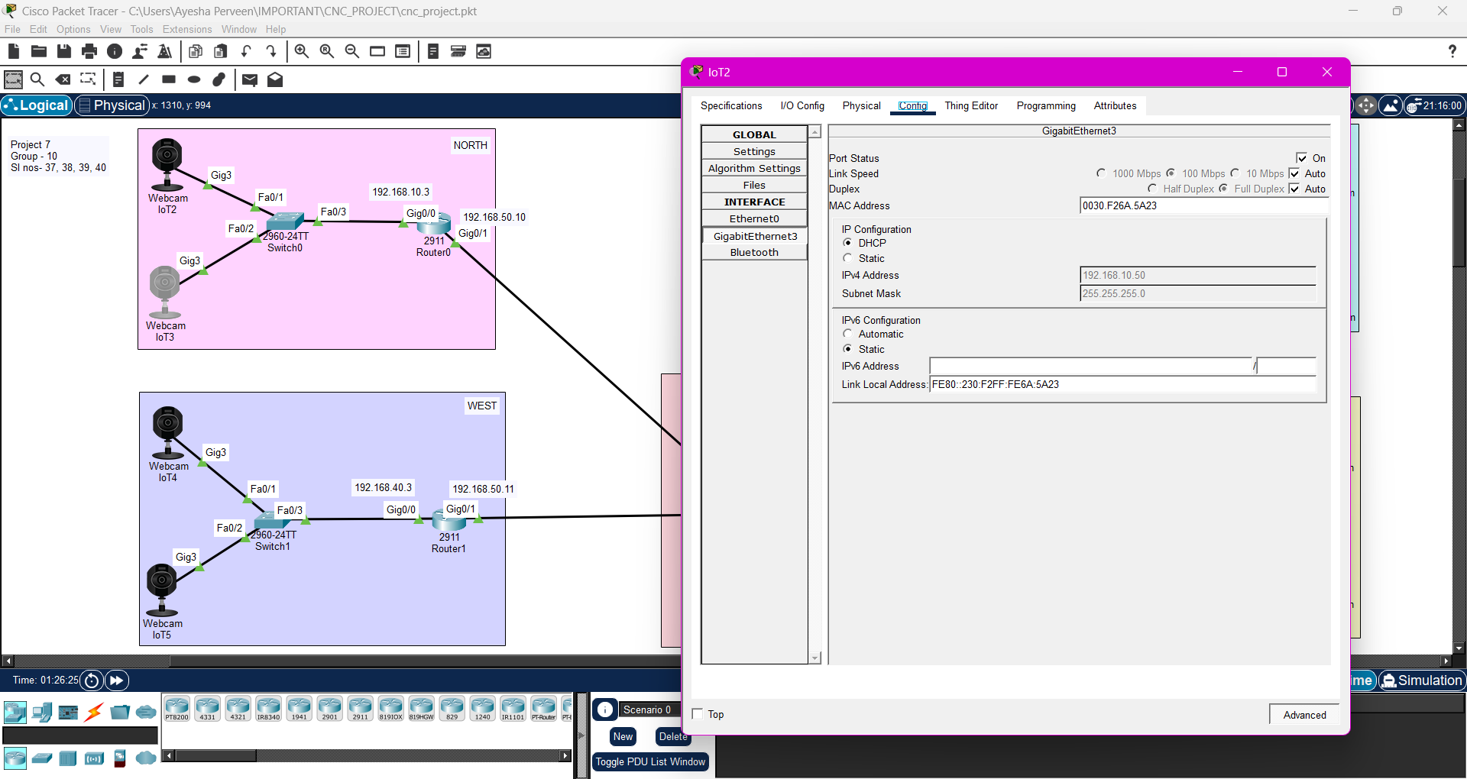
- IP Assignment on Webcam
GROUP-15
SL NO-,57,58,59,
60,61

- Description: This shows the configuration window of Webcam IoT2 with a successfully leased IP address.
- Purpose: It verifies that the DHCP Relay (ip helper-address) is working correctly, allowing devices in remote zones to get their "digital IDs" from the central CMC server.
- CMC Router CLI - Static Routing
- Description: A screenshot of the Command Line Interface (CLI) on Router2 showing the ip route commands.
- Purpose: It demonstrates the "return routes" configured so the central system can communicate back to the specific IP ranges of each city zone

Static Routing & NAT Configuration (Router2)
- Static Routes: The first four ip route commands establish the "digital pathways" back to the North, East, South, and West zones so the server can communicate with the cameras.
- Interface NAT Assignment: The ip nat outside (on Gig0/0) and ip nat inside (on Gig0/1) commands define the boundaries between the public internet and the private city network.
- Static NAT Mapping: The ip nat inside source static command creates a permanent bridge, mapping the private CMC Server (192.168.50.1) to the public IP address (200.0.0.10).
- NAT Translation Table: The final show ip nat translation command confirms the mapping is active, proving the vehicle owner can successfully reach the monitoring center from the public network.
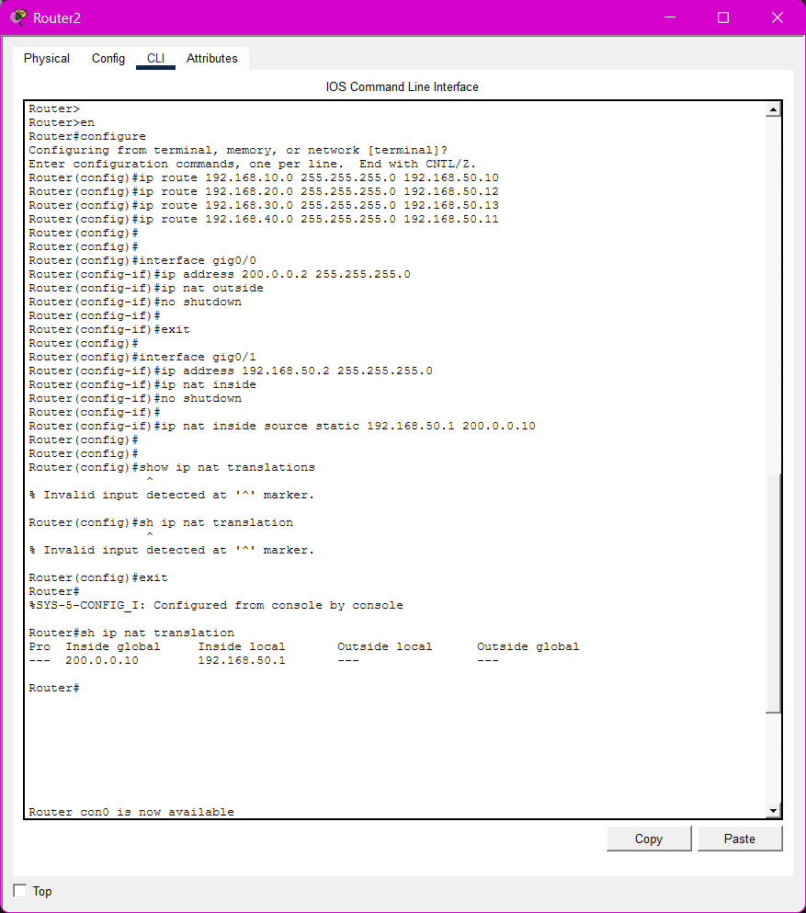

- NAT Translation Table
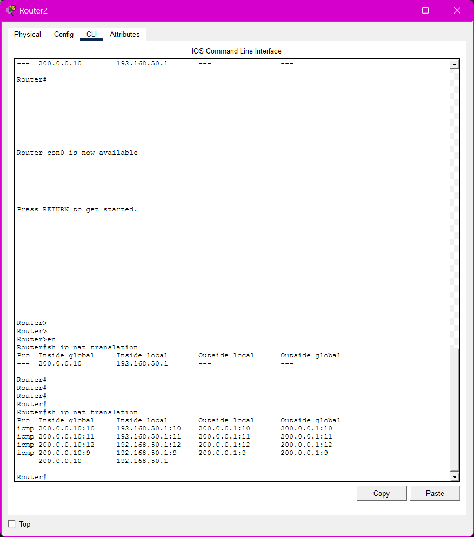
- Description: The output of the show ip nat translations command on the CMC Router.
- Purpose: This is the "Proof of NAT." It shows the mapping between the private server IP (192.168.50.1) and the public-facing IP (200.0.0.10). It verifies that the vehicle owner can securely reach the CMC over the public network.

- End-to-End Ping Verifications
- Description: Successful ping outputs from the Server0 and Public PC command prompts.
- Analysis: These results satisfy Deliverables 4a and 4b:
  - Internal Proof: ping 192.168.10.50 shows the CMC can talk to cameras across zones.
4 a: Ping from CMC server to camera
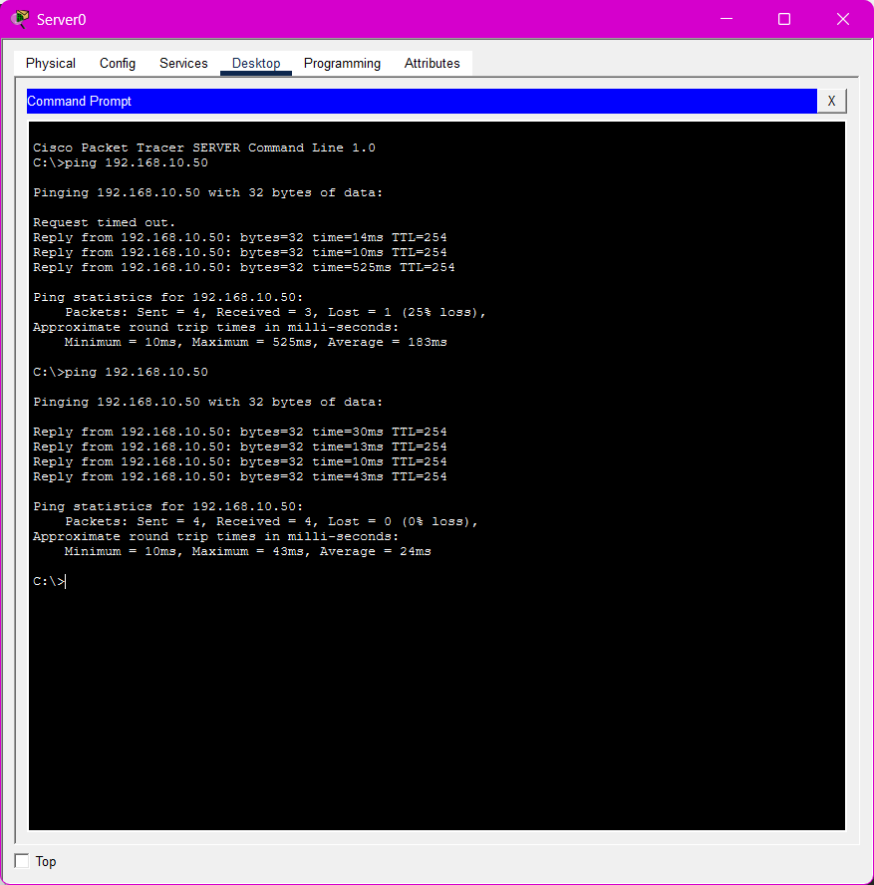

  - External Proof: ping 200.0.0.10 from the Public PC shows the vehicle owner can successfully reach the CMC server through the NAT gateway.
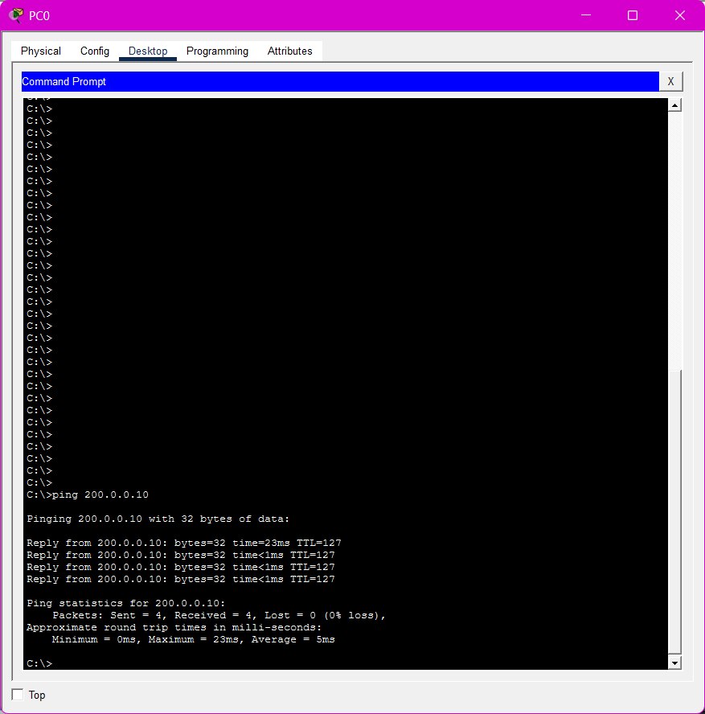
4 b:

- Conclusion
The Smart City Traffic Surveillance Network has been successfully modeled and verified in Cisco Packet Tracer, fulfilling all specified requirements for Project 7. Through a structured design approach, we achieved the following:
- Logical Segmentation: The city was divided into North, East, South, and West zones, each with its own subnet, to maintain an organized and scalable network hierarchy.
- Centralized DHCP Management: A master DHCP server was configured at the Central Monitoring Centre (CMC) to handle all IP requests. By using DHCP Relay Agents (ip helper-address) on zone routers, we automated the IP assignment process for cameras in remote zones.
- Routing & Connectivity: Inter-zonal communication was established using manually configured static routes on all routers, ensuring stable "digital pathways" for traffic data to reach the monitoring authorities.
- Secure Public Integration: The deployment of Static NAT on the CMC Router successfully bridged the private city network with the public network. This allows the CMC to communicate with the vehicle owner (IP: 200.0.0.10) without exposing internal infrastructure to external threats.
- Operational Verification: Final testing via end-to-end pings confirmed 0% packet loss between the CMC server and cameras, as well as between the CMC and the public vehicle owner.
This implementation demonstrates a robust framework for real-time traffic monitoring, data storage, and public notification, ready for smart city deployment.

References

(as per the IEEE recommendations)
[1] G. D. Singh, CompTIA Network+ N10-008 Certification Guide, 2nd ed. Birmingham, UK: Packt Publishing, 2021.
[2] Cisco Systems, Inc., "Static NAT Configuration Guide," Cisco Networking Academy, 2024. [Online]. Available: https://www.netacad.com/
[3] J. Postel, "Internet Protocol," RFC 791, Internet Engineering Task Force (IETF), 1981.
[4] Siksha 'O' Anusandhan (Deemed to be University), "Project 7: Smart City Traffic Surveillance Network," Computer Networking and Concepts (CSE 3751) Lab Manual, 2025.
[5] T. Lammle, Cisco Certified Network Associate (CCNA) Study Guide, 2nd ed. Indianapolis, IN: Sybex, 2020.

